Assignment 2 fixes using SQL Commands:

In my assignment 2 I added the new works to the database based on the current date. Since the date has changed since then I decided to check if the move date of a work is todays date then it should be changed to the date that assignment 2 was due. (Oct 19th). This will allow me to recreate my database using the same files I handed in for assignment 2.
In my assignment 2 I also realized that I did not add works into the museum on their date of acquisition but rather on a certain date of July 1st. I decided to use a insert statement to fix all of the works that I put into storage on the first assignment. I then deleted these works from the database if their locMoveDate was July 1st. I then updated all of the galleries to fix their locMoveDates to the start of the exhibition rather than the specific July 1st that I had decided on previously I made sure that the date of aquasition of all my works was before the first exhibition.

A3Q1:
To show the exhibitions with their number of works I used a simple select command with attributes from my exhibitions, rooms, exhibitLocations, and exhibitWorks tables. I used the count function to count the number of works attributed to each exhibition in the exhibitWorks table.

To add works to the exhibitions I manually checked that the works I needed to add would not conflict with the times that the other exhibitions are in progress then I added them manually using two insert statements; two for the worksLocations table and one for the exhibitWorks table.
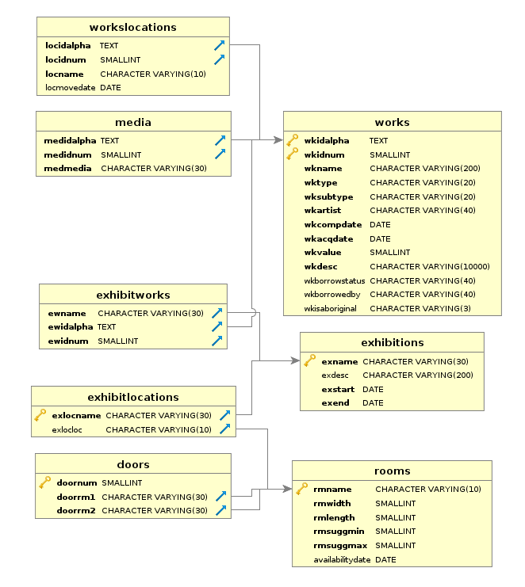
A3Q2:

I manually inserted the new works using individual insert statements for each row of the works table and the media table.
To represent selling two works I decided to create a new room called “Sold” which would represent works that are no longer in the museum. I then inserted the only three works that had spent their entire time at the museum in storage with the sold location.
To keep track of when the museum owns or is borrowing works I decided to create a new table called workOwner. This table is used to prepare for when works can be borrowed at one point and owned at another. The table has one column for date and is a closed-open temporal structure because it is not known if in the future a work will be owned/borrowed again.
The creation of this new table made the wkBorrowedBy column in the works table redundant so I removed it.
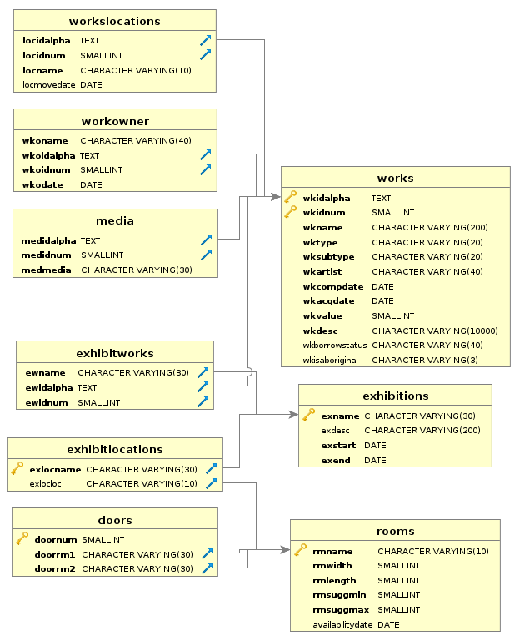

A3Q3:

To facilitate the need to know times that the works location moves I started by changing the datatype of the locMoveDate column to a timestamp.
I then went through the necessary commands needed to create three exhibitions; I made the exhibitions in the exhibitions table, I made a list of all works that will be going into each exhibition and added those to the exhibitWorks table, and I inserted into the worksLocations table times when the works will be in the exhibitions they are associated to.

Since my worksLocations table is a closed-open temporal data style I found it very difficult to specify where a specific work is at a given time. Due to this my command only shows when the works move between Nov1 2015 and Nov1 2016.

Since my exhibitions are stored in a closed-closed temporal database it was easy to check if a certain exhibition was going on between two dates. I did this with a simple select statement.
It was also easy to check the location between two dates since that info is also based off of thee dates that the exhibitions happen. I did that with a simple select statement.
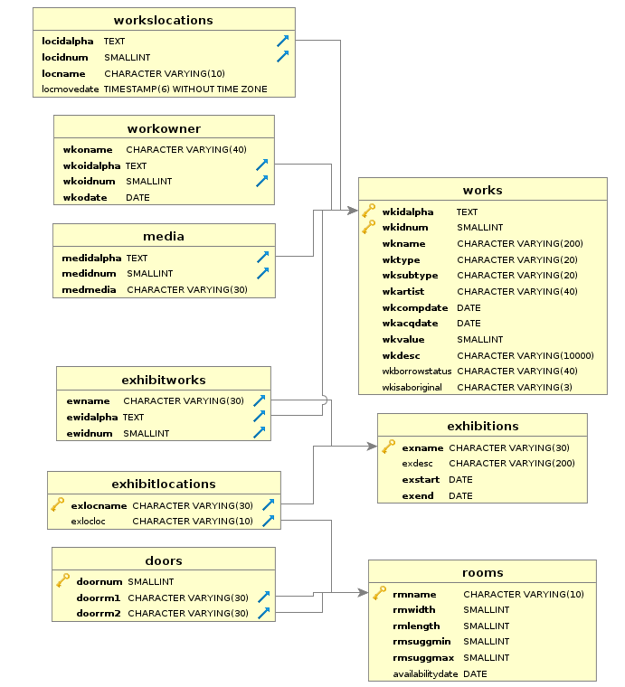

A3Q4:

To facilitate the idea of a load being lent out I first added a new room to the rooms table called ‘on loan’ so symbolize when a particular work is on loan.
I then created a table titled workload that holds all the required information on another museum that is loaning a particular artwork.
I then selected 6 works to be put on loan and added their new location to the worksLocations table and also added that work into the workLoan table with all of the info of the museum the work has been sent to.
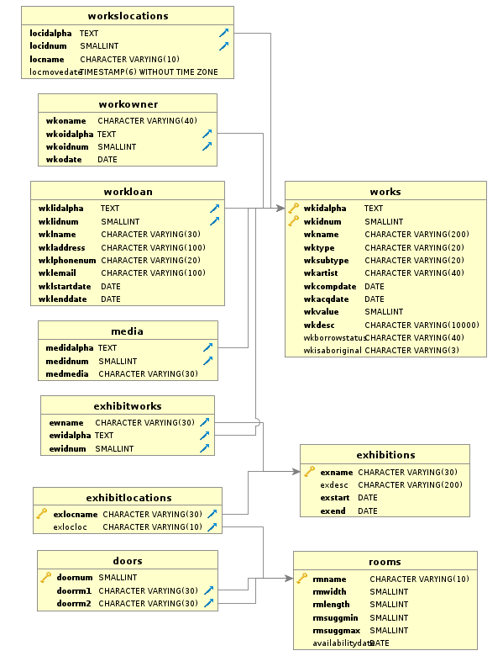

A3Q5:

I started off by creating a new table called travelingExhibitLocations to facilitate all the required info for a particular temporary location the exhibition will be at.
I then created an exhibition and added it to the exhibitions table, then added works into this exhibition by adding them to the exhibitWorks table.
I then inserted temporary locations into the travelingExhibitLocations table. 